# Datasets

Finding open datasets now becomes easier than before, we used one dataset provided by Dubai government and another one found on Github.com then we used a public API from Foursquare.com.

## Dubai neighborhoods dataset

About Dataset

A dataset which contains neighborhood name along with its latitude and longitude.

Source

[Github.com](https://gist.github.com/amlapierre/1cef140b0315a32778e4ecdde78b4b0a" \l "file-dubai_neighborhoods-csv)

Sample response

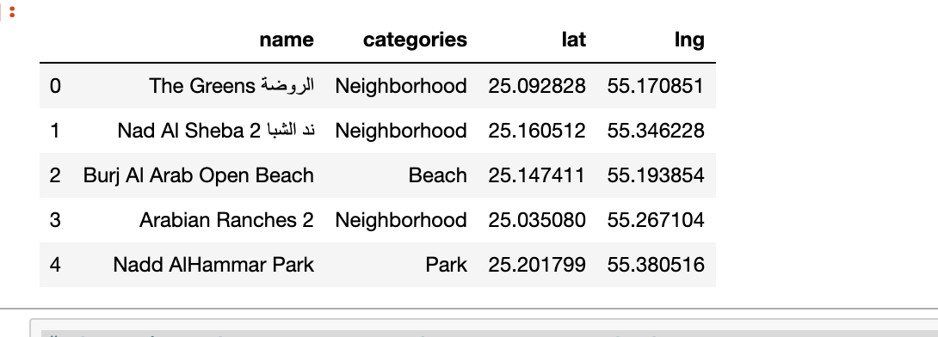

## Dubai metro stations dataset

About Dataset

A dataset which contains metro stations name and metro line along with its latitude and longitude.

Source

[Dubaipulse.gov.ae](https://www.dubaipulse.gov.ae/data/rta_metro_stations-open/datafiles/ac7932e2-63c7-4780-9c87-2de1c114d732/rta-rail?organisation=rta&service=rta-rail#preview)

Sample response

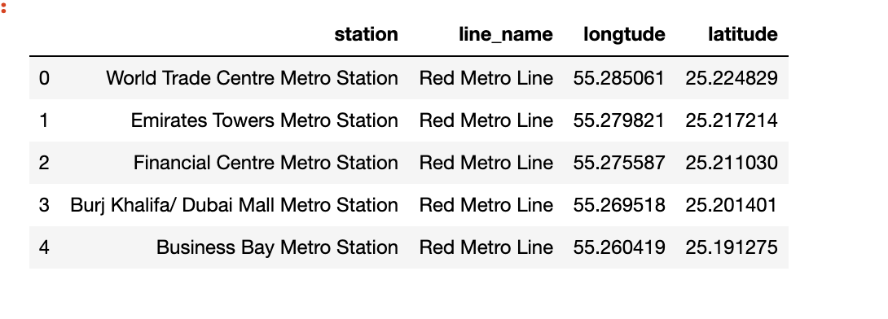

## Nearby venues api

About api

Returns a list of recommended venues near the current location.

Source

[Foursquare.com](https://developer.foursquare.com/docs/api/venues/explore)

Sample response

|  |
| --- |
| {      **"meta"**:{         **"code"**:200,       **"requestId"**:"5ac51ef86a607143de8eg5cb"    },    **"response"**:{         **"warning"**:{            **"text"**:"There aren't a lot of results near you. Try something more general, reset your filters, or expand the search area."       },       **"suggestedRadius"**:600,       **"headerLocation"**:"Lower East Side",       **"headerFullLocation"**:"Lower East Side, New York",       **"headerLocationGranularity"**:"neighborhood",       **"totalResults"**:230,       **"suggestedBounds"**:{            **"ne"**:{               **"lat"**:40.724216906965616,             **"lng"**:-73.9896507407283          },          **"sw"**:{               **"lat"**:40.72151724718017,             **"lng"**:-73.98693222860872          }       },       **"groups"**:[            {               **"type"**:"Recommended Places",             **"name"**:"recommended",             **"items"**:[                  {                     **"reasons"**:{                        **"count"**:0,                      **"items"**:[                           {                              **"summary"**:"This spot is popular",                            **"type"**:"general",                            **"reasonName"**:"globalInteractionReason"                         }                      ]                   },                   **"venue"**:{                        **"id"**:"49b6e8d2f964a52016531fe3",                      **"name"**:"Russ & Daughters",                      **"location"**:{                           **"address"**:"179 E Houston St",                         **"crossStreet"**:"btwn Allen & Orchard St",                         **"lat"**:40.72286707707289,                         **"lng"**:-73.98829148466851,                         **"labeledLatLngs"**:[                              {                                 **"label"**:"display",                               **"lat"**:40.72286707707289,                               **"lng"**:-73.98829148466851                            }                         ],                         **"distance"**:130,                         **"postalCode"**:"10002",                         **"cc"**:"US",                         **"city"**:"New York",                         **"state"**:"NY",                         **"country"**:"United States",                         **"formattedAddress"**:[                              "179 E Houston St (btwn Allen & Orchard St)",                            "New York, NY 10002",                            "United States"                         ]                      },                      **"categories"**:[                           {                              **"id"**:"4bf58dd8d48988d1f5941735",                            **"name"**:"Gourmet Shop",                            **"pluralName"**:"Gourmet Shops",                            **"shortName"**:"Gourmet",                            **"icon"**:{                                 **"prefix"**:"https://ss3.4sqi.net/img/categories\_v2/shops/food\_gourmet\_",                               **"suffix"**:".png"                            },                            **"primary"**:true                         }                      ],                      **"popularityByGeo"**:0.9999983845502491,                      **"venuePage"**:{                           **"id"**:"77298563"                      }                   }                }             ]          }       ]    } } |